









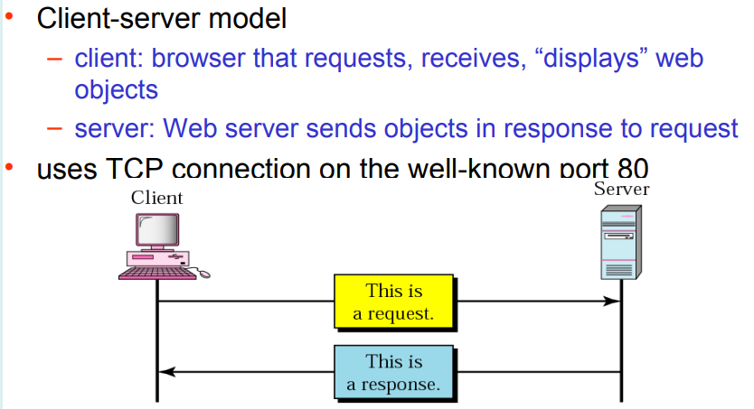

DNS Domain name System

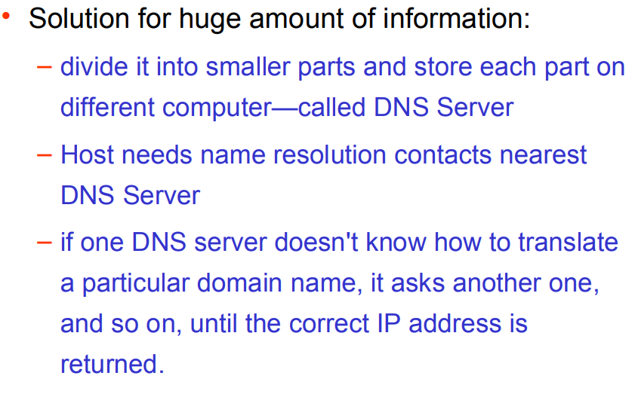

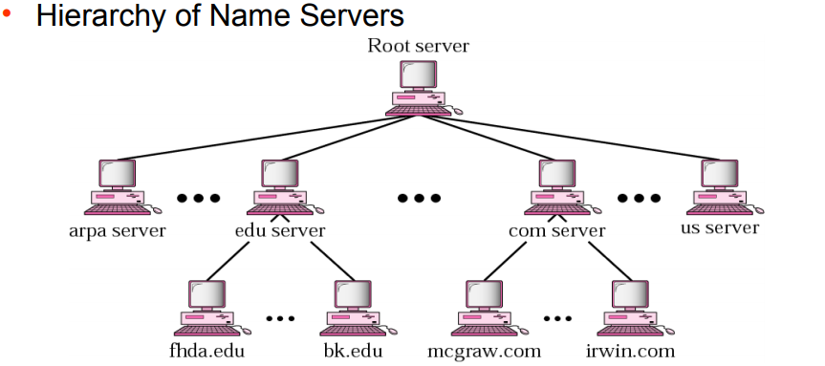

DNS zones, servers –

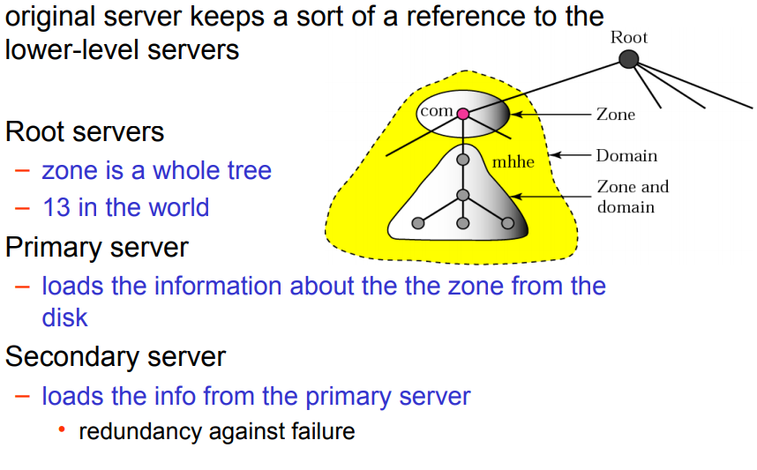

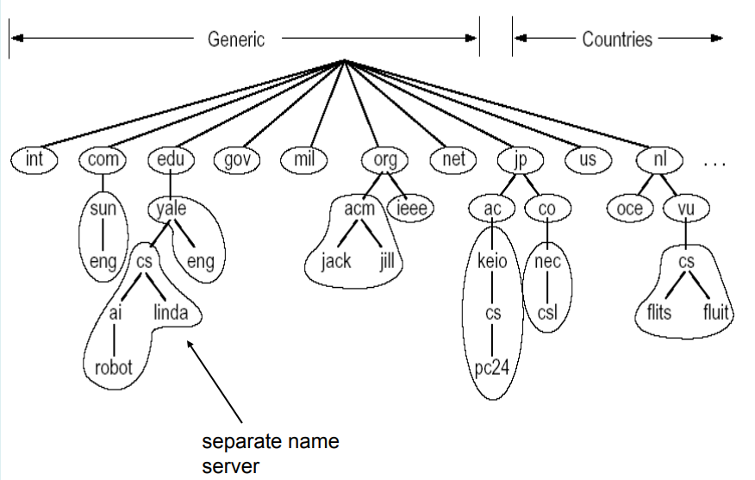



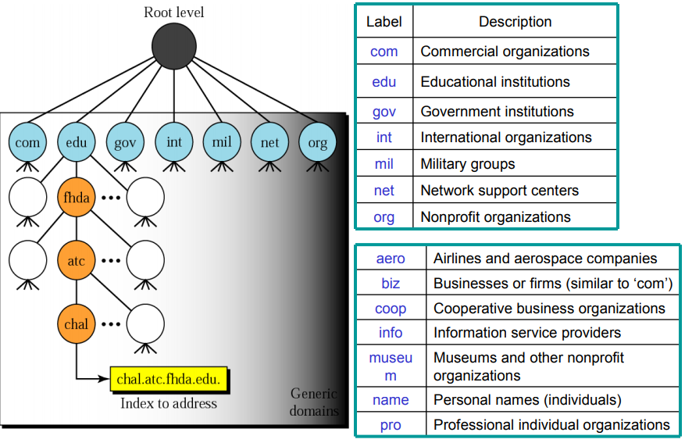



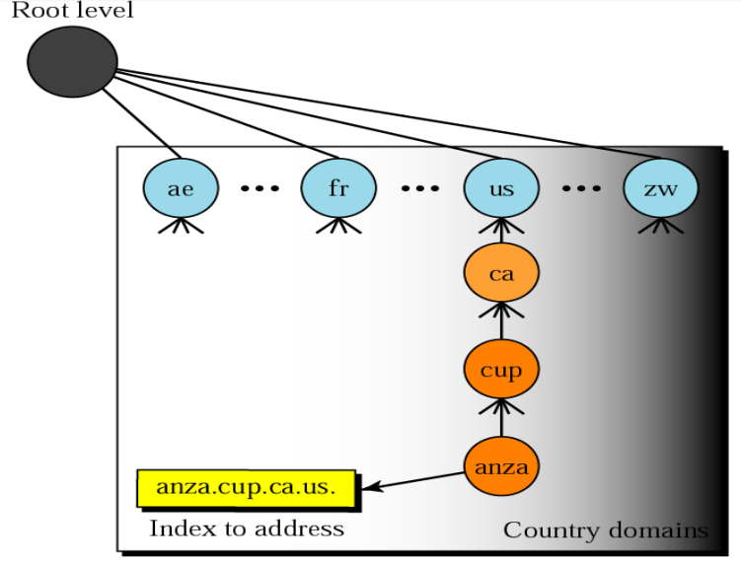



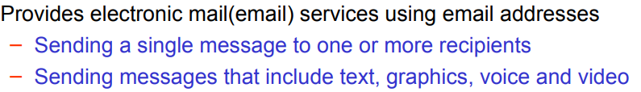



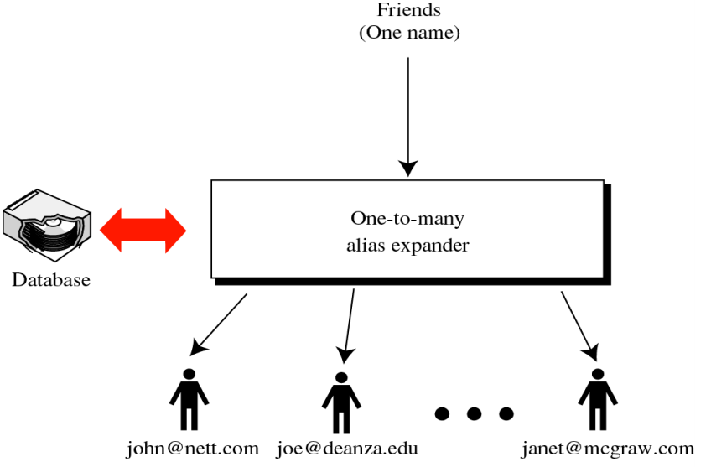



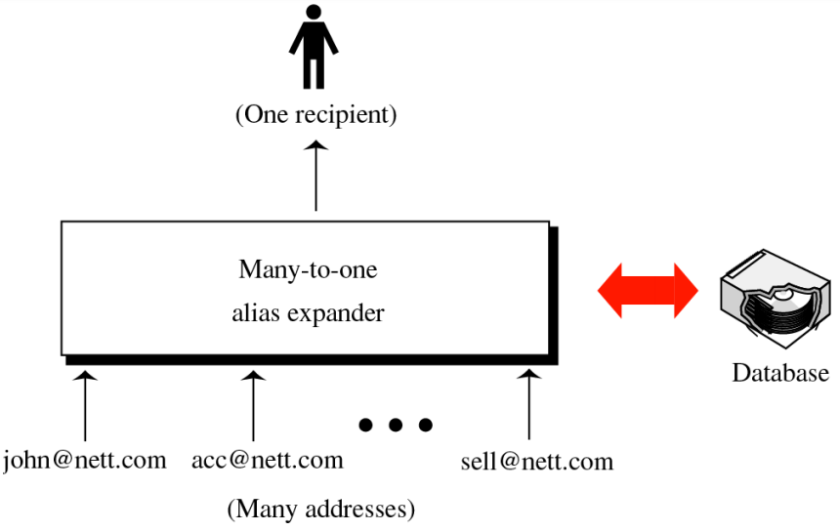



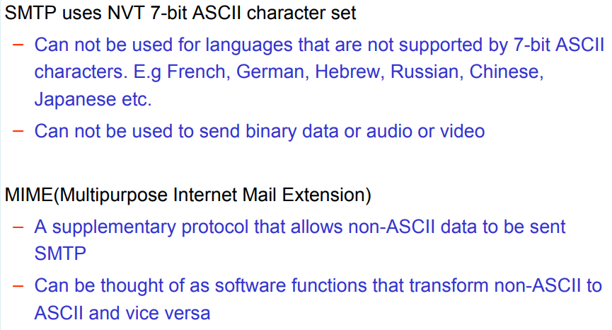

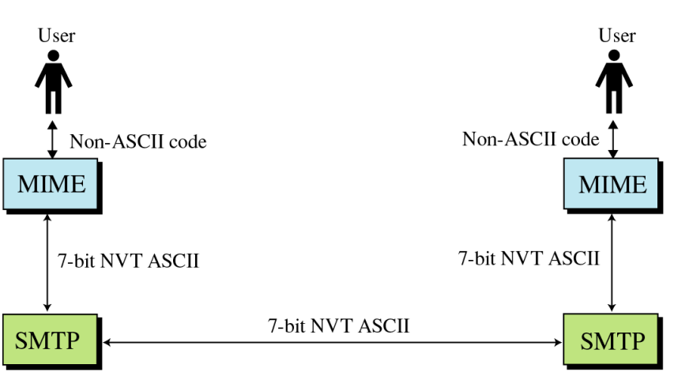

Subnet

A subnetwork or **subnet** is a logical subdivision of an IP network. The practice of dividing a network into two or more networks is called **subnetting**. Computers that belong to a **subnet** are addressed with an identical most-significant bit-group in their IP addresses.

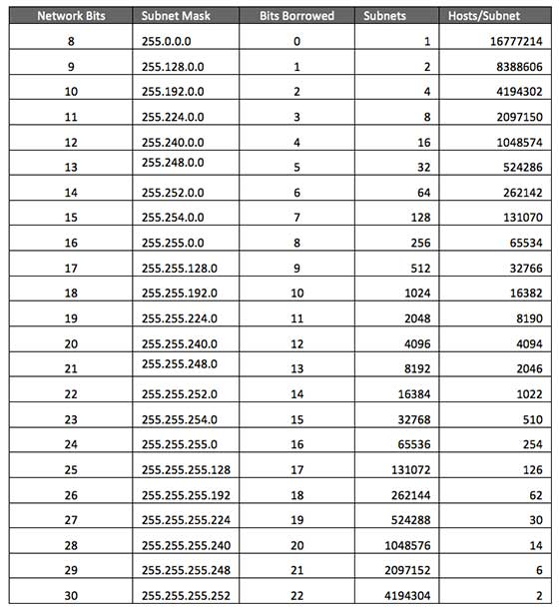

**Supernetting** is the opposite of Subnetting. In subnetting, a single big network is divided into multiple smaller subnetworks. In **Supernetting**, multiple networks are combined into a bigger network termed as a Supernetwork or **Supernet**.

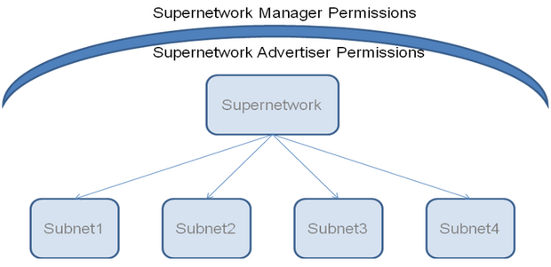

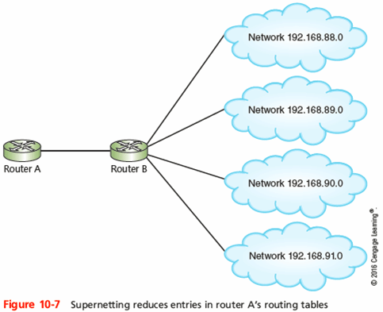

Variable-Length Subnet Masking (**VLSM**) amounts to "subnetting subnets," which means that **VLSM** allows network engineers to divide an IP address space into a hierarchy of subnets of different sizes, making it possible to create subnets with very different host counts without wasting large numbers of addresses.

